CP CHEMISTRY MP 1 EXAM REVIEW PACKET Name:

CHAPTER 2

- a) State the law of conservation of matter and energy ____in any chemical or physical process, matter and energy cannot be created or destroyed. _______
b) Hydrogen reacts with oxygen to produce water. 2 H₂ + O₂ → 2 H₂O.

How many grams of hydrogen reacts with 32 grams of oxygen to produce 36 grams of water?

2 H₂ + O₂ → 2 H₂O
4 grams H₂

x + 32 g = 36 g

- Matter is defined as___ anything that has mass and takes up space (has volume)________.

- What is a physical property? quality of a substance that can be observed or measured without changing the identity of the substance

Example: ____ color __________ Example: _ freezing-point ____

- What is a chemical property? ____ quality that describes how a substance reacts _________________

Example: ____ rusts _____________ Example: ____ bake/cook ______

- What is a physical change? a change during which some properties of a material change, but the composition of the material does not change

Example: ___ tear/rip _________ Example: ____ boil ________

- What is a chemical change? a change that produces matter with a different composition than the original matter

Example: _____ rot ____________ Example: _____ react ___________

- Define element the simplest form of matter that has a unique set of properties; an element cannot be broken down into simpler substances by chemical means.

- Define compound a substance that contains two or more elements chemically combined in a fixed proportion.

- Define homogeneous mixture: a mixture that is uniform in composition; components are evenly distributed and not easily distinguished.

- Define heterogeneous mixture: a mixture that is not uniform in composition; components are not evenly distributed throughout the mixture.

- Classify each as either an element, a compound, homogeneous or heterogeneous mixture.
- salt ___compound_____________________
- distilled water ___compound_____________________
- soil ___homogenous or heterogeneous mixture____________
- air ___homogeneous mixture____________
- carbon dioxide ___compound_____________________
- gold ___element_______________________
- brass ___homogeneous mixture (alloy)____________
- oxygen ___element________________________
- mayonnaise ___homogeneous mixture____________
- sea water ___heterogeneous mixture____________

- What two things are classified as pure substances?___ compounds _____ and ____ elements ______

- Describe each of the following separation techniques:

- crystallization a process that separates homogeneous mixture (liquid evaporates and crystal stays behind)

b) distillation a process used to separate components of a mixture using differences in boiling points

- filtration a process that separates a solid from the liquid in a heterogeneous mixture

CHAPTER 3
- The density of sulfur is 2.06 g/cm³. Find the volume of 34.9 grams of sulfur.

V = $\frac{m}{D}$ = $\frac{34.9 g}{2.06 g/cm3}$
16.94 cm³

- A piece of iron (mass = 47.5 grams) is placed into a graduated cylinder filled with 50.0 ml of water. The new volume reading on the graduated cylinder is (with the metal) is 62.0 ml. Calculate the density of iron.

V = 62.0 ml – 50.0 ml = 12.0 ml
3.96 g/ml
D = $\frac{m}{v}$ = $\frac{47.5 g}{12.0 mL}$

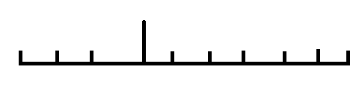

- Make the following metric conversions using dimensional analysis.

a) 0.044 m = __44.00______ mm b) 0.063 kg = ___0.14_____ pound

0.044 m 1000 mm 0.063 kg 1000 g 1 pound
1 m 1 kg 454g

1 foot = 12 inches
2.54 cm = 1 inch
5280 ft = 1 mile

- Convert 0.50 miles to m.
804.7 m
0. 50 miles 5280 ft 12 inches 2.54 cm 1 m
1 mile 1 foot 1 inch 100 cm

- Read each piece of lab equipment below:

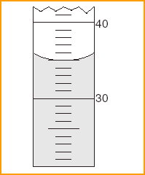 ___35.0__ mL 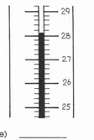____28.1_____ °C

- Define mass ______ the amount of matter that an object contains _________________

- Define volume ____ the space occupied by a sample ____________________________________

10. State the use of each piece of lab equipment listed below and what it is used to measure:
a. beaker: holds liquids (mL)
b. funnel: to put solids or liquids into another container.
c. graduated cylinder: to measure precise volumes of liquids (mL)
d. balance: measures mass (g)
e. stirring rod – used to stir solutions
f. ruler – used to measure length (cm)

CHAPTER 4

- Atoms are composed of __protons________, __neutrons__________, and __electrons_____.

- The mass number of an element is the total number of __ protons ______ + ___ neutrons ________

- Define atom ____ smallest particle of an element that retains its identity in a chemical reaction _____

- C-12 and C-14 are isotopes. What does that mean? ____they are atoms of the same element that have the same atomic number but different atomic masses due to a different number of neutrons____.

______________________________________________________________________________________

Complete the table using the periodic table. Round when necessary.

Isotopic Notation | # of protons | # of neutrons | # of electrons | charge
${}_{37}^{85}{Rb}$⁺ | 37 | 48 | 36 | +1
${}_{11}^{23}{Na}$⁺ | 11 | 12 | 10 | +1
${}_{35}^{80}{Br}$⁻ | 35 | 45 | 36 | -1
¹²C | 6 | 6 | 6 | 0
¹⁴C | 6 | 8 | 6 | 0

- There are two isotopes of lithium, Li-6 and Li-7, found in nature at 7.50% and 92.5% respectively. Calculate the average atomic mass of lithium.

(6)(7.50) + (7)(92.5)
6.9 amu
100

- Determine the mass of 0.25 moles of silver.

0.25 moles 107.9 g Ag
27.0 g Ag
1 mole

- How many atoms are in 45 g of aluminum?

1.0 x 10²⁴ atoms
45 g Al 1 mol 6.02 x 10²³ atoms
27.0 g Al 1 mol

CHAPTER 5

- All waves have what four properties? __ wavelength ______, ______ frequency ______

________ energy ______________ and ______ amplitude __________

- Arrange the types of electromagnetic radiation listed below in order of INCREASING (smallest to largest) energy, wavelength and frequency:

red light, violet light, radio waves, gamma rays
energy: _radio_________ < __red__________ < __violet___________ < __gamma_______

wavelength: _gamma________ < __violet________ < __red____________ < __radio_______

frequency: __radio_________ < __red__________ < __violet___________ < __gamma_____

- If you double the energy of a wave, the wavelength will ________ cut in half _____________.

Sketch a graph for this relationship:
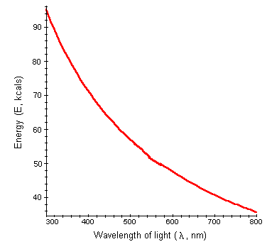
- If you cut the frequency of a wave in half, the energy will _________ cut in half _____________.

Sketch a graph for this relationship:
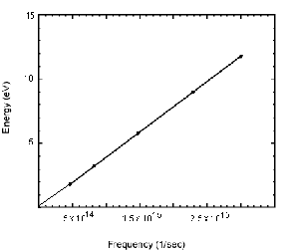

- When an electron jumps from the excited state to the ground state, it _____releases____ energy in the form of light.

CHAPTER 25

- Complete the chart:
Name | Symbol | Charge | Mass | Level of Radiation
Alpha | ${}_{2}^{4}{He}$ or α | 2+ | 4 | Low  (0.05 mm body tissue)
Beta | ${}_{-1}^{0}e$or β | 1– | 1/1837 ~ 0 | Moderate  (4 mm body tissue)
Gamma | γ | 0 | 0 | Very high  (penetrates body easily)

- Complete the following nuclear reactions:

- ${}_{92}^{238}U$ (alpha decay) ${}_{92}^{238}U$ ${}_{2}^{4}{He}$ + ${}_{90}^{234}{Th}$
- ${}_{10}^{24}{Ne}$ (beta decay) ${}_{10}^{24}{Ne}$ ${}_{11}^{24}{Na}$+ ${}_{-1}^{0}e$
- ${}_{94}^{239}{Pu}$ ${}_{2}^{4}{He}$ + ${}_{92}^{235}U$

- ${}_{92}^{238}U$ + ${}_{0}^{1}n$→${}_{93}^{239}{Np}$ + ${}_{-1}^{0}β$

CHAPTER 6

- Label what each of the following parts of the orbital diagram represents, then identify the name of the element ending with this electron configuration:
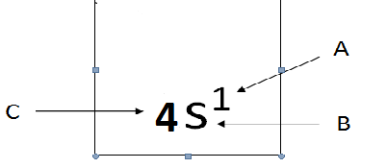
A. number of electrons
B. sublevel
C. energy level

Name of the element: Strontium

- Complete the chart below using the Periodic Table.

Element | Electron Configuration  (complete or abbreviated) | Electron Dot Diagram
₁₄Si | [Ne] 3s²3p² | 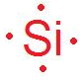
₃₈Sr

₂₅Mn

- What was Mendeleev’s contribution to the development of the periodic table?_____________________

___ he designed the first periodic table according to atomic mass __________

- How did Moseley change Mendeleev’s periodic table? _______________________________________

___ he rearranged the periodic table so it was organized by atomic number _____________

- State the Periodic Law. when the elements are arranged in order of increasing atomic number, there is a periodic repetition of their physical and chemical properties

4. 4. Rows on the periodic table are called_____________ periods _________________________________

5. Columns on the periodic table are called groups_________________

6. Name the following:
a) Group I b) Group II c) Group VII
alkali metals alkaline earth metals halogens

d) Group VIII e) the “d” block f) the “s” block
noble gases transition metals alkali, alkaline
g) elements on the staircase
metalloids

- A metal ________ loses ______________ electrons in an ionic bond.

- Nonmetals normally ____gain______ electrons in an ionic bond or ______share________ electrons in a covalent bond.

- Define ionization energy and state its trend on the periodic table.

Definition: __ the energy required to remove an electron from an atom _____________

Trend: _____ increases across and up the periodic table _______________________

Circle the element with higher ionization energy: Al or S F or I F or Ne

- Define electronegativity and state its trend on the periodic table.

Definition: __ the ability of an atom to attract electrons ______________________________

Trend: __ increases across and up the periodic table (except NOBLE GASES)___

Circle the element with higher electronegativity: Al or S F or I F or Ne

- Define atomic radius and state its trend on the periodic table.

Definition: __ one-half the distance between the nuclei of two adjacent atoms ________________

Trend: _____ increases to the left and down the periodic table __________________

Circle the element with the larger radius: Al or S F or I

- When K turns into K¹⁺, does it get larger or smaller? Why?

It gets smaller because the K atom loses an electron, so the nuclear pull on the remaining electrons is greater. It also loses an energy level__________

- When O turns into O²⁻, does it get larger or smaller? Why?

It gets larger due to the increased amount of electrons. The nuclear pull is less on the greater number of valence electrons in the outer most energy level. Also, shielding remains constant.___________________

- List the 7 diatomic elements.

_H₂____ __N₂____ __F₂____ __O₂____ __I₂____ __Cl₂____ _Br₂_____

- How many molecules are in 44.0 g of nitrogen gas?
9.5 x 10²³ molecules
44.0 g N₂ 6.02 x 10²³ molecules
28 g N₂

CHAPTER 7-8 (Bonding)

16. a. Complete the chart below:
molecule | VSEPR diagram | geometry  (linear, bent, trigonal pyramidal, trigonal planar, tetrahedral) | angle | nonpolar/polar?
CH₂Cl₂ | 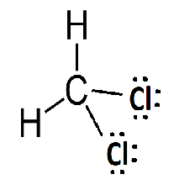 | tetrahedral | 109.5° | polar
HCN | 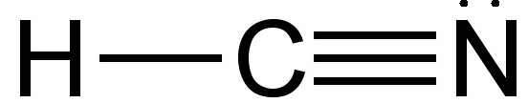 | linear | 180° | polar
NI₃ | 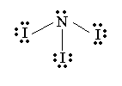 | pyramidal | <109.5° | polar

b. Draw the Lewis structure for the compound below:

Compound | Before bonding | After bonding
AlF₃ |  | 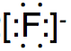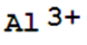 3
Li₂O | 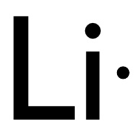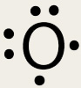 | 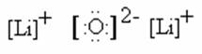

17. Use the electronegativity values and scale provided to determine the type of bond that exists between the listed pair of atoms within a compound.

Element | Electronegativity
Rb | 0.8
Ca | 1.0
H | 2.1
O | 3.5
Cl | 3.0

Difference in electronegativity
4.0 1.7 0.4 0
Ionic | Polar-covalent bond | Non-polar covalent bond

a) Ca-Cl in CaCl₂  3.0-1.0 = 2.0  IONIC | b) Rb – O in Rb₂O  3.5 – 0.8 = 2.7  IONIC | c) H-O in H₂O  3.5-2.1 = 1.4  POLAR COVALENT

18. Mole Conversions for Ionic Compounds

- How many moles are in 12.3g of sodium chloride? 0.21 mol NaCl

- Find the mass of 4.85 x 10²⁴ formula units of potassium nitride. 1,057.90g K₃N

- How many molecules are in 25.5g fluorine? 4.04 x 10²³ mlc F₂

d) How many moles are in 5.36 x 10²⁵ atoms of carbon? 0.89 mol C

CHAPTER 9 (Nomenclature)

19. Name the following

a) P₂O₅ diphosphorus pentoxide
b) CaCO₃ calcium carbonate
c) CCl₄ carbon tetrachloride
d) NH₄F ammonium fluoride
e) AlN aluminum nitride
f) Mg(NO₂)₂ magnesium nitrite

20. Write formulas for the following:

- lead (IV) sulfide PbS₂
- magnesium chloride MgCl₂
- sulfur dibromide SBr₂
- dinitrogen trioxide N₂O₃
- ammonium oxide (NH₄)₂O
- chromium (III) hydroxide Cr(OH)₃
- dinitrogen tetraoxide N₂O₄
- iron (II) nitrite Fe(NO₂)₂
- sodium carbonate Na₂CO₃

Chapter 10 Chemical Quantities

21. FORMULA WRITING & MOLAR MASS
NAME | FORMULA | WORK for MOLAR MASS CALCULATION | FINAL ANSWER
Nickel (II) hydroxide | Ni(OH)₂
dicarbon tetrachloride | C₂Cl₄ | 2C = 2 x 12.01 = 24.02  4 Cl = 4 x 35.45 = 141.8 | 165.82 g/mol  C₂Cl₄
Calcium Nitrate | Ca(NO₃)₂ | 1 Ca = 1 x 40.1 = 40.1 +  2 N = 2 x 14.01 = 28.02 +  6 O = 6 x 16 = 96 | 164.12 g/ mol  Ca(NO₃)₂

22. Find the percent composition (% of each element) for calcium nitrate.

40/164 *100 = 24.39 %
28.02/164 *100 = 17.07 %
96/164 *100 = 58.54 %
% Ca _24.4%_____

%N _17.1%_______

% O _58.5%_______

23. Determine the mass of calcium in 47.0g of calcium nitrate.

b. Determine the mass of calcium nitrate that contains 12.0g of calcium

24. Mole conversion Covalent Compounds

a. How many molecules are in 14.0 g of dicarbon tetrachloride.

14.0 g C₂Cl₄ 1 mole C₂Cl₄ 6.02 x 10²³ molecules C₂Cl₄ = 5.08 x 10²² molecules C₂Cl₄
165.82 g C₂Cl₄ 1 mole C₂Cl₄

b. Find the mass of 1.50 moles of dicarbon tetrachloride.
249.0 g C₂Cl₄
1.50 moles C₂Cl₄ 165.82 g C₂Cl₄ =
1 mole C₂Cl₄

25. A student does a lab to determine the molar mass of barium chloride. In lab, he determines the mass to be 216.0 g/mol. Find his percent error.

BaCl₂ = (1 x 137.3) + (2 x 35.5) = 208.3 g/mol (actual)

Percent error = experimental value - actual value x 100% = 3.56%
actual value

Percent error = 216.0 - 208.3 x 100% = 3.70%
208.3
3.70%

26. The following information is obtained in a CuSO₄ • X H₂O hydrate lab:
3.70%
mass of the evaporating dish | 22.00g
mass of the evaporating dish and hydrate | 24.50g
mass of the evaporating dish and anhydrous powder | 23.59g

a) Find the mass of hydrate:

b) Find the mass of anhydrous compound:

c) Find the mass of the water driven off.

Chapter 14 Gases

27. What are the three components to the kinetic theory (for gases)?

- The particles in a gas are assumed to be small, hard spheres with an insignificant volume.

- The motion of particles in a gas is rapid and random.

3. All collisions between gas particles and the walls of the container they are in are perfectly elastic.

28. Pressure and volume of a gas at constant temperature are inversely proportional. If the volume of a gas triples, its pressure will decrease by one third

29. Volume and temperature of a gas at constant pressure are directly proportional. If the volume of a gas triples, its temperature will triple

30. Pressure and temperature of a gas at constant volume are directly proportional. If the temperature of a gas triples, the pressure will triple

31. If two containers are at the same temperature and pressure and their volumes are equal, they must contain the same number of particles

32. Molecules of oxygen gas and nitrogen gas are at the same temperature in equal sized flasks. Which molecules are moving faster? Nitrogen since one N₂ molecule is lighter than one O₂ molecule (N₂ has a molar mass of 28g/mol and O₂ has a molar mass of 32 g/mol)

33. If the oxygen gas molecules and nitrogen gas molecules in the scenario above are all at the same temperature, which gas has the greatest average kinetic energy? Neither - temperature is a measure of average kinetic energy, and the temperature for both substances is the same

34. A balloon is filled with 3.0 L of helium at 1 atm. What is the volume of the balloon when the pressure is only 0.25 atm? (ans: 12L)

Formula: P₁ V₁= P₂V₂
(1 atm)(3.0L)= (0.25atm)(x)
x= 12L

35. The gas left in a used aerosol can is at a pressure of 3.4 atm at 27.0°C. If this can is thrown into a fire, what is the pressure of the gas when its temperature reaches 500.0°C? (ans: 8.8 atm)

Formula: P₁ = P₂ 3.4 atm = P₂ = 8.8ATM
T₁ T₂ 300 K 773 K

36. 5.2 L of a gas is at STP. Find the new volume when the temperature rises to 38°C and the pressure drops to 600.0 mmHg. (ans: 7.5L)

Formula: P₁V₁ = P₂V₂ (760mmHg)(5.2L) = (600mmHg)(V₂) = 7.5L
T₁ T₂ 273K 311K

37. Find the volume occupied by 14.0g of carbon dioxide at 25ºC and 0.880atm. (ans: 8.84L)

Formula: PV = nRT

14.0g CO₂ 1 mol CO₂ = 0.32 mol CO₂
44g CO₂

0.88atm (V) = 0.32mol(0.0821)(298K)
V = 8.84 L

